**Windows Instructor Guide for MEASURE**

Faculty of Engineering, McMaster University

January 9, 2020

**by**

Evan Situ, Michelle Zheng, Spencer Smith, and Andrew Aran

**Modification Log**

|  |  |  |  |
| --- | --- | --- | --- |
| **Version** | **Modification Date** | **Author** | **Comments** |
| 3.00 | January 9, 2020 | Andrew Aran | * Updated to reflect MEASURE 3.0 |

Click here to view previous modification log.

Table of Contents

Introduction 4

Prerequisites 5

Windows 5

System Requirements 5

About the Vena Add-In 5

Installing Vena Add-In for Windows Users 5

Enabling Trust Access to the VBA Project Object Model 6

Other Operating Systems 8

Instructions to Access a Virtual Machine: 8

Questions/Comments/Technical Support: 8

Annual Timeline 9

Accessing Vena 11

Changing Vena Password 11

Instructor Input 12

Vena Checklist 12

Windows Guide 12

Accessing Rubric Input Template 12

Updating Rubric Input Template 14

Viewing Summary Chart 17

Viewing Detailed Chart 18

Reports 19

Accessing the Reports 20

CEAB Attribute Report 21

Vena’s Drill Down Feature 21

Faculty and Curriculum Committee Recommendation Report 22

Historical Course Measurement Report 23

Historical Program Measurement Report 24

Measurement Map Report 25

Cascade 26

Generating a Mass Course Report 26

Appendix I: Report Overview 28

Appendix II: Previous Modification Log 29

# Introduction

The Instructor’s Guide describes part of MEASURE (McMaster Engineering Accreditation System for UndeRgraduatE).

MEASURE’s purpose is to:

* Facilitate the continual improvement of the curriculum of the programs offered by the Faculty of Engineering
* Assist with generating accreditation reports for the Canadian Engineering Accreditation Board (CEAB)

MEASURE is built using corporate performance management software, (Vena) that combines Excel spreadsheets, a central database, and workflow management.

This document outlines the MEASURE tasks that take place at the instructor level.

Specifically, each instructor will update the Rubric Input Template for each section of every course taught.

Additional information on MEASURE can be found in the Administrator’s Guide and in the Department Contributor’s Guide. The latest version of all these documents, along with other resources, are available at <http://measure.mcmaster.ca>

Issue Reporting: <https://www.eng.mcmaster.ca/forms/measure-issue-tracking>

Technical Support: [measure@mcmaster.ca](mailto:measure@mcmaster.ca)

# Prerequisites

## Windows

### System Requirements

|  |  |  |
| --- | --- | --- |
|  | **Recommended** | **Minimum** |
| **Operating System** | Latest version of Windows 10 (64-bit) | Windows 7 (32-bit) |
| **MS Office** | Office 2016 or newer   * Click [here](https://www.mcmaster.ca/uts/licensing/msemployees.html) for instructions to download Office (via UTS) | Office 2010 |
| **.NET** | Latest version of .NET | 4.5 |
| **Browser** | Latest version of:   * Internet Explorer * Microsoft Edge * Mozilla Firefox * Google Chrome | * Internet Explorer 10+ * Microsoft Edge * Mozilla Firefox 12.0+ * Google Chrome |
| **RAM** | 16 GB | 4 GB |
| **CPU** | 2+ Cores | -- |
| **Reference:** | <https://support.venasolutions.com/hc/en-us/articles/115000622006-Vena-Add-In-System-Requirements> | |

### About the Vena Add-In

Vena uses both Microsoft Excel and the Vena website (<https://vena.io>) to give users access to the rubric input template and various accreditation reports. Before users can update their course data in Excel, they will need to install the Vena Add-In for Microsoft Excel. This Add-In provides functionality to Excel that allows users to view, edit, and save their rubric data to the Vena cloud.

### Installing Vena Add-In for Windows Users

1. Visit the add-in website <http://addin.vena.io/release/vena.application>
2. Save the **vena.application** file
3. Double-click the **vena.application** file



1. Run the installer. The following dialog box will appear:

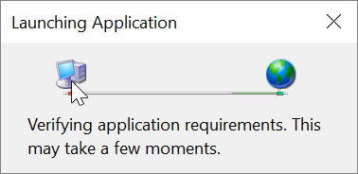

1. When the application has loaded, press **Install**

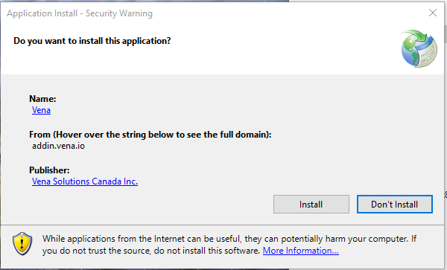

1. When the installation has completed, the following dialog box will appear. **Close** this dialog box to complete the installation.

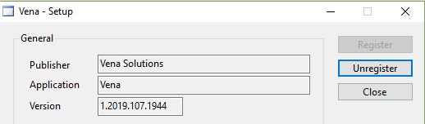

1. To ensure Vena has successfully installed, open Microsoft Excel, and confirm the Vena tab has been added.

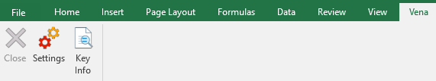

### Enabling Trust Access to the VBA Project Object Model

After installing the Excel Vena Add-in, access to the VBA project object model will need to be trusted for Vena to run properly.

1. Open **Excel**
2. Select a **Blank Workbook**
3. Select **File**

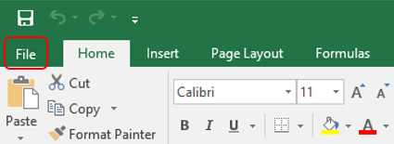

1. On the bottom of the left menu, select **Options**

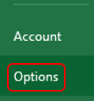

1. Select **Trust Center**
   1. Select **Trust Center Settings**

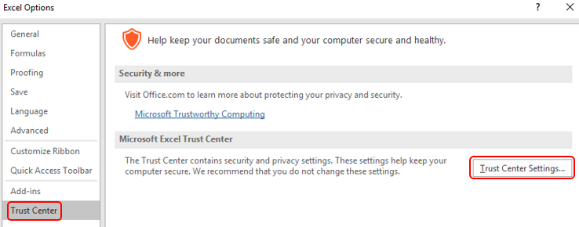

1. Select **Marco Settings**
2. Ensure that **Disable all macros with notification** is selected
3. Check the box next to **Trust access to the VBA project object model**

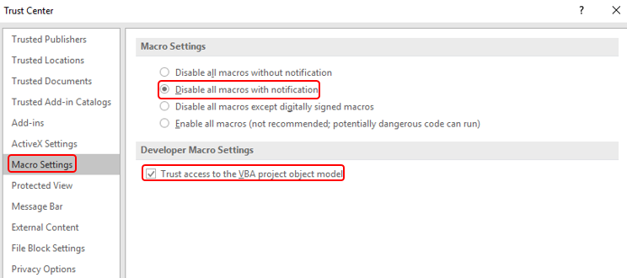

1. Close all instances of Excel for the settings to take effect.

## Other Operating Systems

Vena is currently compatible for Windows and macOS users with Microsoft Office. Users who do not have a compatible operating system and/or Microsoft Office will need to access Vena using a virtual machine.

### Instructions to Access a Virtual Machine:

<https://www.eng.mcmaster.ca/sites/default/files/vminstruct.pdf>

### Questions/Comments/Technical Support:

[measure@mcmaster.ca](mailto:measure@mcmaster.ca)

# Annual Timeline

The table below summarizes the typical tasks performed during the course of an academic year.

Instructor responsibilities are highlighted in **green**.

|  |  |  |  |  |
| --- | --- | --- | --- | --- |
| **Date** | **Task Description** | **Section** | **Template** | **Task Owner** |
| January | * Instructor enters rubric and continuous improvement plan for Term 1 | Windows  macOS | Rubric Input Template | Instructor |
| January | * Instructor reviews the continuous improvement plan from the previous year for Term 1 | Click here | Rubric Input Template and Curriculum Committee Recommendations Report (Prev. Year) | Instructor |
| January | * Review current rubric entry status * Contact users who have yet to complete their Vena rubric entry | Department Guide | See Department Guide | Department |
| April | * Update global variable and point to Term 2 (after Term 1 data entry is complete) | Admin Guide | See Administrator’s Guide | Associate Dean’s Office |
| May | * Instructor enters rubric and continuous improvement plan for Term 2 | Windows  macOS | Rubric Input Template | Instructor |
| May | * Instructor reviews continuous improvement plan from the previous year for Term 2 | Click here | Rubric Input Template and Curriculum Committee Recommendations Report (Prev. Year) | Instructor |
| May | * Review current rubric entry status * Contact instructors who have yet to complete their Vena rubric entry | Department Guide | See Department Guide | Department |
| May | * Curriculum committees review (this year) course reports and continuous improvement plan reports | Department Guide | See Department Guide | Department |
| August | * Archive previous year | Admin Guide | See Administrator’s Guide | Associate Dean’s Office |
| * Start New Academic Year |
| * Update global variable and point to Term 1 (after Term 2 data entry is complete) |
| August | * Update Measurement Mapping | Department Guide | See Department Guide | Department |
| August | * Update Curriculum Mapping   + Consult with Instructors | Department Guide | See Department Guide | Department |
| August | * Update Curriculum Recommendations | Department Guide | See Department Guide | Department |
| August | * Review Programs in Vena * Notify Associate Dean’s Office if changes are needed | Department Guide | See Department Guide | Department |
| August | * Add/Update/Un-map courses in the Vena Database * **Do not delete Courses** | Department Guide | See Department Guide | Department |
| September | * Faculty reviews departmental continuous improvement plan report from previous year * Prepare/review Graduate Attribute Report | Admin Guide | See Administrator’s Guide | Associate Dean’s Office |
| December | * Execute Backup and Restore Process | Admin Guide | See Administrator’s Guide | Associate Dean’s Office |

# Accessing Vena

1. Open a web browser
2. Visit <https://vena.io>
3. In the email textbox, enter your McMaster email address (i.e. [macid@mcmaster.ca](mailto:macid@mcmaster.ca))
4. Your password has been previously communicated. If you do not remember, or do not have an account, please contact Measure Support ([measure@mcmcaster.ca](mailto:measure@mcmcaster.ca))

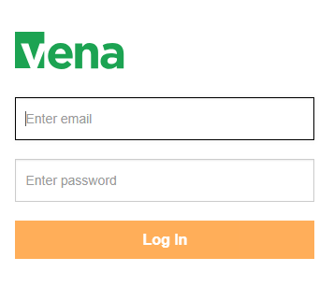

# Changing Vena Password

Your password can be changed by clicking the user’s name in the upper right corner of the screen and then selecting “Change Password”.

You will be prompted to enter the current and new password.

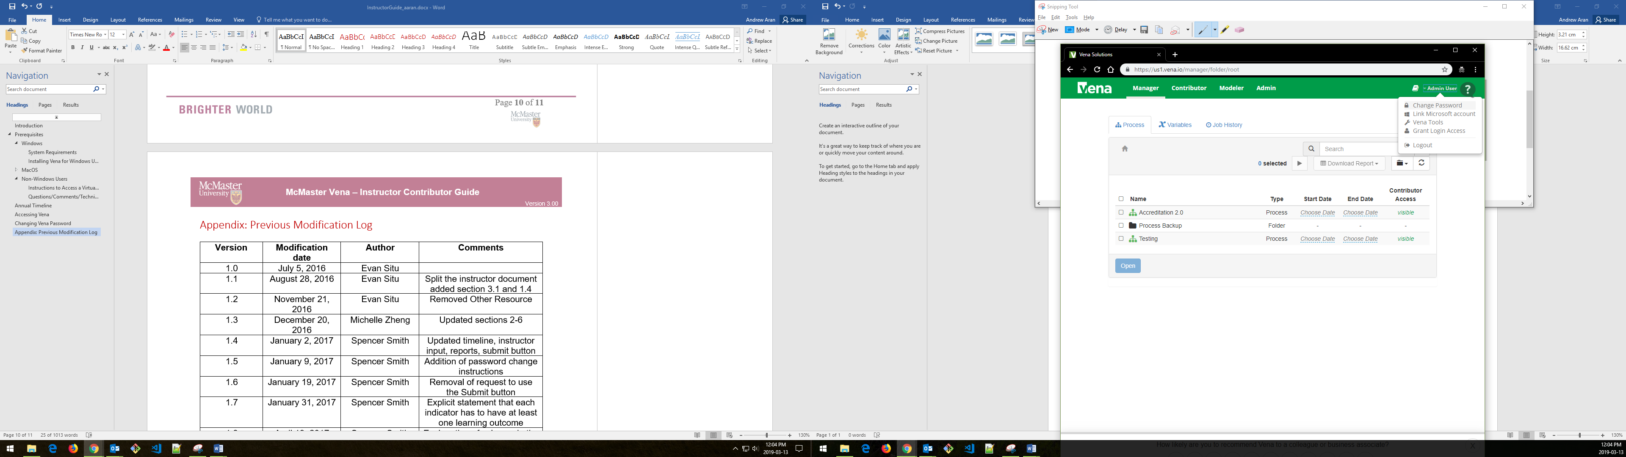

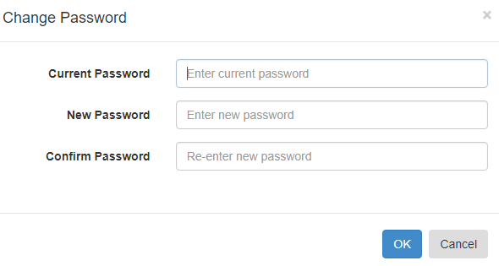

# Instructor Input

For each course being measured, the continuous improvement plan and rubric data will need to be entered and saved. They will need to be entered in a single spreadsheet called the Rubric Input Template.

When the data entry for the Rubric Input Template is complete, you are done. Although the Vena interface shows a Submit button, the button is disabled.

**\*\*\*You do not need to worry about using the Submit button\*\*\***

## Vena Checklist

Prior to entering/reviewing rubric data with Vena, please ensure the following tasks are complete:

|  |  |
| --- | --- |
| **Task** | **Windows** |
| The device meets the system requirements | Click here |
| Microsoft Excel 2010 or later is installed | Click [here](https://www.mcmaster.ca/uts/licensing/msemployees.html) |
| Vena Add-In is installed | Click here |
| Enabling Trust Access to Vena | Click here |

## Windows Guide

This section of the guide is intended for Windows (7/8/10) operating system users.

### Accessing Rubric Input Template

1. Under Contributor view, select Task **Rubric Input & Course Report (by Instructor) - New**

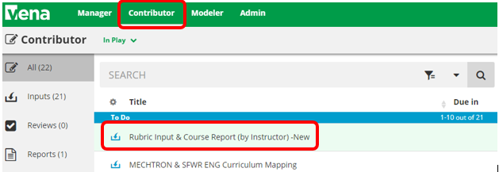

1. Select **Check Out** beside the **Rubric Input Template – Windows.xlsm**



1. A pop-up will appear to save the template. Click **save** and remember the saved location of the template.

|  |  |
| --- | --- |
| Google Chrome | Mozilla Firefox |
|  |  |

Microsoft Edge:



1. Open the Excel File
   1. If prompted, press Enable Editing in the Excel spreadsheet



* 1. If prompted, press Enable Content to allow Macros



1. Selecting the Course, Year, and Section
   1. **Program:** Select the course for data entry. Pressing the dropdown will let users see the list of available courses. However, typing the course name in the textbox will help find it quicker.
   2. **Year:** Press the dropdown button to select the corresponding year and term.
   3. **Section:** The default section is Section 1 (unless otherwise stated).

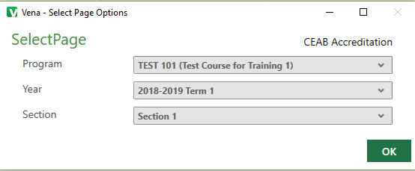

### Updating Rubric Input Template

If an instructor has entered rubric information from the previous year, the same rubric information will be carried over as a starting point for the current year.

If this is the first time a course is being measured, the user may need to insert new learning outcomes (rows) to enter the rubric data.

**Tip:** Users can enter/update data where cells are highlighted in yellow.

1. **Instructor Name**
   1. Enter the instructor’s name for the course
2. **Rubric Entry Status**
   1. Select a status from the dropdown menu
      1. Not Started – User has not entered rubric data
      2. WIP – User has entered rubric data, but not complete
      3. Fully Complete – User has completed entering rubric data

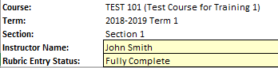

1. **Summary of Actions to be Taken for Continuous Improvement for Next Academic Year**
   1. Instructors can enter their continuous improvement plan(s) under the section “Summary of Actions to be Taken for Continuous Improvement for Next Academic Year”

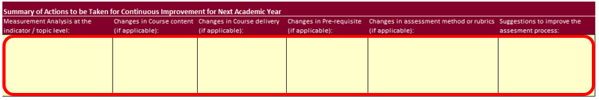

* 1. To attach a file:
     1. Select a cell
     2. Click **Comments**
     3. In the **Comments** section, click **Details** Tab
     4. Click the **Add** **Comment** button
     5. Click the **paper clip** and attach your file
     6. Click **Upload** when asked to upload the file as a comment
     7. Include text in the selected cell such as ‘**See attached file**’ to notify users the template contains attachments

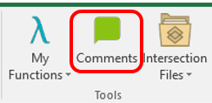

1. **Indicators/Learning Outcomes**

**Indicators** - descriptors of what students must achieve to be considered competent in the corresponding attribute

**Learning Outcomes** – descriptors of what the instructor expects the student to learn to be considered competent in the corresponding indicator

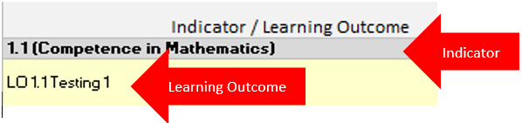

*** Every indicator must have at least (1) learning outcome (row) inserted ***

* 1. **Adding Topics (rows)**
     1. Select an **Indicator** (grey cell)
     2. Click **Insert** under the Vena Tab
        1. A new row will be inserted below the selected indicator
     3. **Enter** the learning outcome in the newly inserted row
  2. **Deleting Topics (rows)**
     1. Select the **Learning Outcome** you wish to remove
     2. Click **Remove** under the Vena Tab
        1. The selected row will be removed
  3. **Missing Indicators**
     1. If an indicator is missing or is not required, please contact your department representative or [MEASURE Support](mailto:measure@mcmaster.ca) to update the Measure Indicators Template

1. **Measurement Date**
   1. Enter the current date in YYYY-MM-DD format (e.g. 2019-12-31, etc.)
2. **Expectations**

**Description**: Describes a given expectation that applies to a learning outcome

**Number**: The numbers in this column should be the number of students that apply to the given category, not the percentage of the class in that category

* 1. **Enter** a description describing each expectation
  2. **Enter** the number of students corresponding to each expectation

1. **Used (1/0)**

The column “Used (1/0)” is set to 1 if the data in a particular row is used for the calculation of the indicator.

If users wish to record the information for future reference, but do not intend for it to be averaged into the indicator, you should enter a 0. The default value is 0.

* 1. **Enter** a **1** or **0** for each row
     1. If you are unsure, enter 1 to include the number with the average indicator

1. **Measurement Category**

The Measurement Category has a dropdown menu with a list of possible values pertaining to the learning outcome (i.e. Assignment, Lab, Exam, etc.)

* 1. **Select** a category from the dropdown menu for each row

1. **Attaching Sample Files**

Reminder: For privacy and security reasons, remove any information that may identify a student

To attach a file:

* + 1. Select a cell
    2. Click **Comments**
    3. In the **Comments** section, click **Details** Tab
    4. Click the **Add** **Comment** button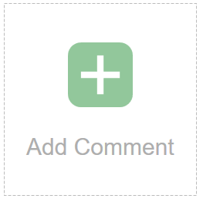
    5. Click the **paper clip** and attach your file
    6. Click **Upload** when asked to upload the file as a comment
    7. Please include text in the field such as ‘See attached file’ to notify users the template contains attachments

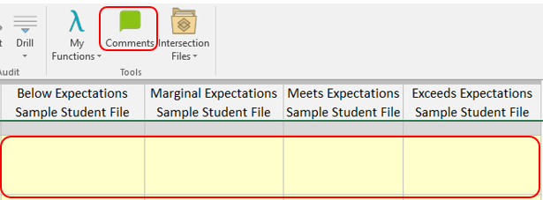

1. **Saving Data**
   1. Select the Vena Tab
   2. Click **Save Data**

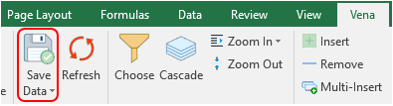

1. **Closing and Checking in the Template**
   1. When closing the Rubric Input Template, you will be prompted to **Check-in**
   2. Select **Yes**

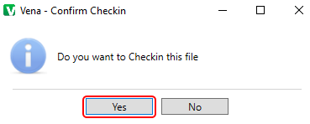

### Viewing Summary Chart

The Summary Chart is a graphical summary of every Indicator containing rubric course data. The chart may contain up to four bars where each bar represents an Expectation.

After entering/updating rubric data:

1. Press **Save Data**
2. Press the **Refresh** button under the Vena tab
3. Select the **Summary Report** worksheet

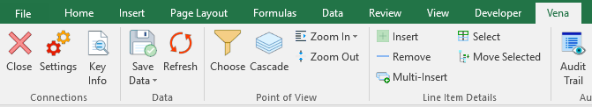

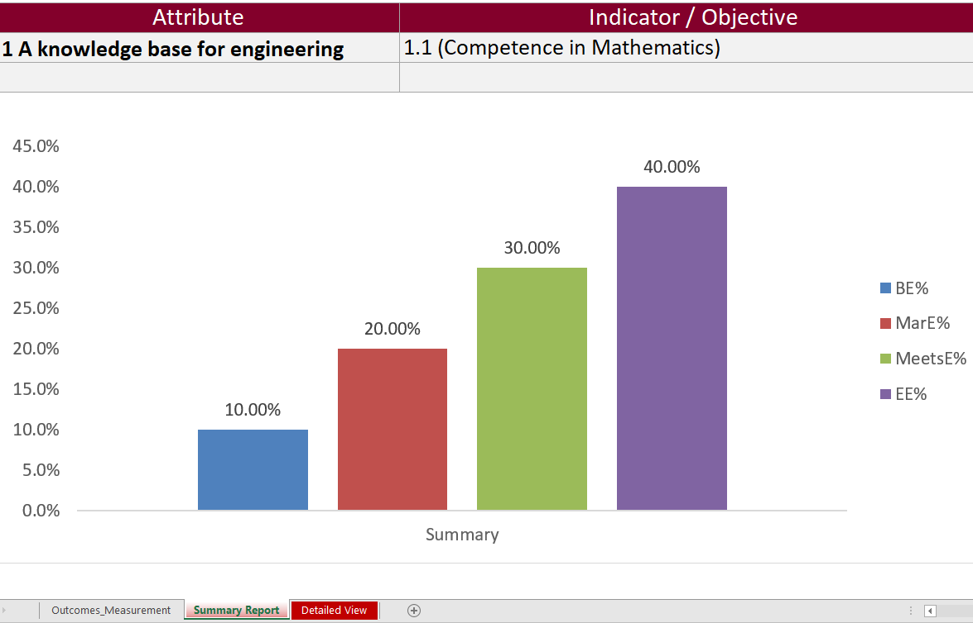

### Viewing Detailed Chart

The Detailed Chart is a graphical summary of every Learning Outcome containing rubric course data. Every learning outcome may contain up to four bars where each bar represents an Expectation.

After entering/updating rubric data,

1. Press **Save Data**
2. Press the **Refresh** button under the Vena tab
3. Select the **Detailed View** worksheet



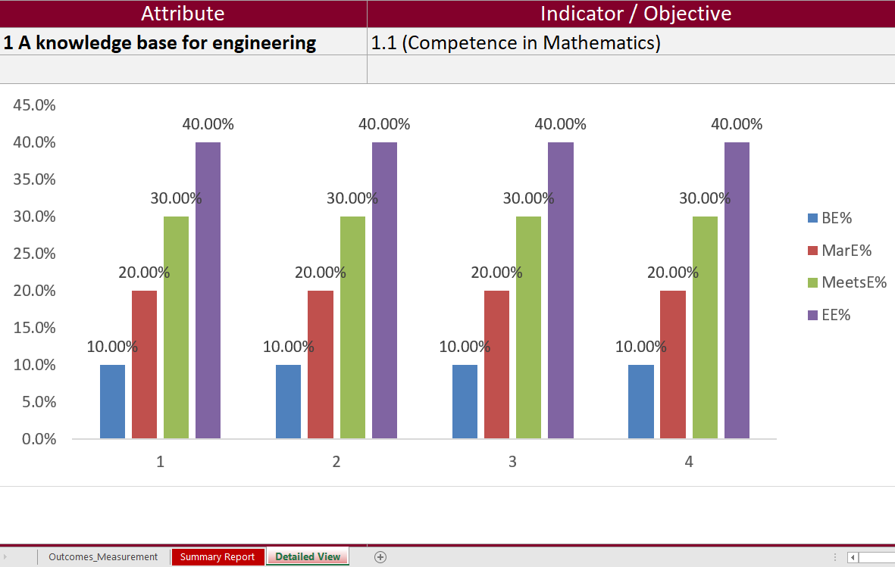

# Reports

Throughout the year, instructors can look at the reports generated by MEASURE. These reports can help fill out the CEAB questionnaire during the accreditation years.

Most of the report types are described in the Departmental Guide. However, the reports that are of particular interest to instructors are described here.

The Vena Reports are best viewed using a Windows-based operating system.

In particular, instructors will want to view:

* CEAB Attribute Report
* Faculty and Curriculum Committee Recommendation’s Report
* Historical Course Measurement Report
* Historical Program Measurement Report
* Measurement Map Report

## Accessing the Reports

1. Ensure the Contributor tab is selected

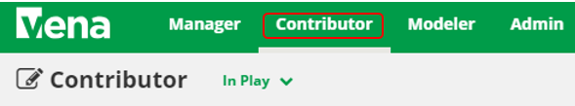

1. On the left side, click **Reports** (the centre section will reload to only display Reports)

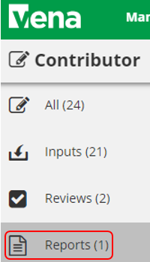

1. Click **Reports**

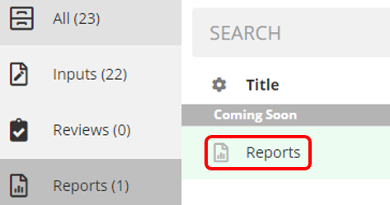

## CEAB Attribute Report

The CEAB Attribute Report displays the attribute results of a given program/course by year or term. Each bar in the report represents a Graduate Attribute. The bar may divide into 4 expectations.

The line indicates the average score for each attribute where 1 = Below expectations and 4 = Exceeds expectations.

1. Press **View** next to CEAB Attribute Report
2. Select a Course/Program, Term, and Section
3. **Download** and remember the saved location of the report

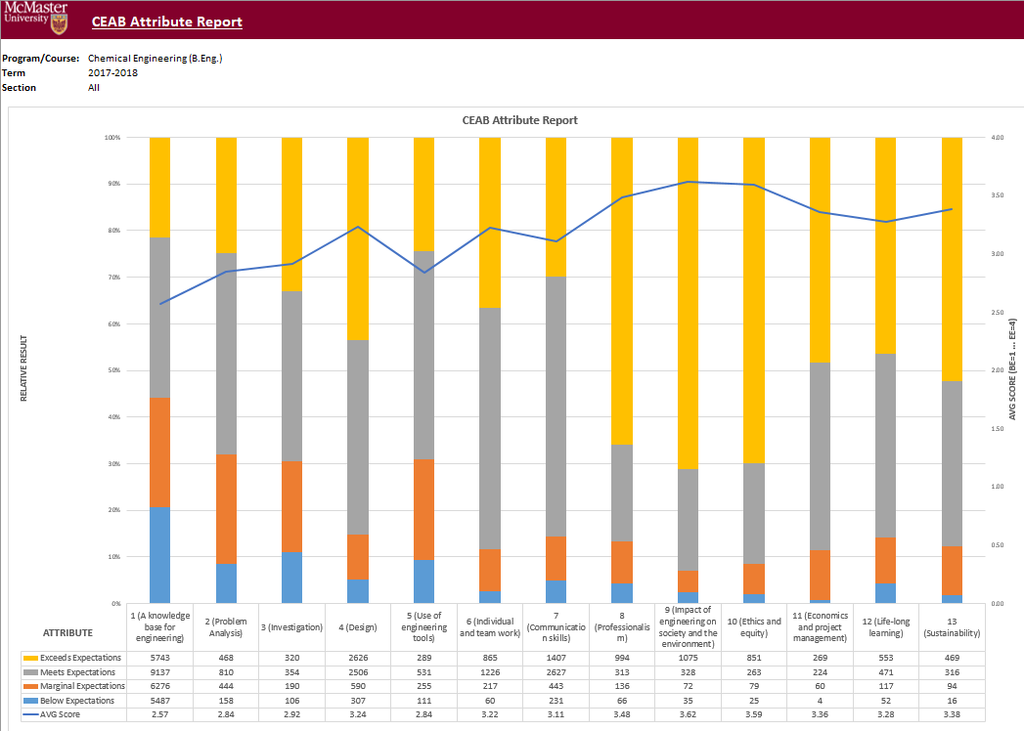

### Vena’s Drill Down Feature

The Drill down feature enables users to view the raw data making up the sum of a selected expectation.

1. Select a cell intersecting an Attribute and Expectation

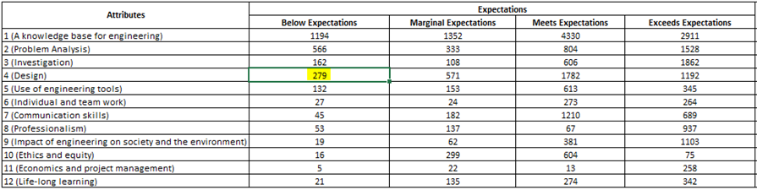

1. Select Drill Down
   1. For **Windows users**, select Vena Tab 🡪 Drill 🡪 Drill Down

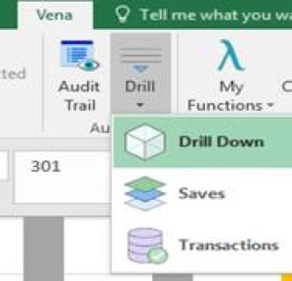

* 1. For **macOS users**, select Drill Down
  2. 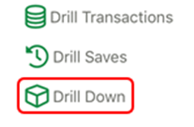

1. A new Excel worksheet will be generated displaying a breakdown of the data by course, year, attribute, section, value, etc.
   1. The sum of the value column will equal the value of the selected cell

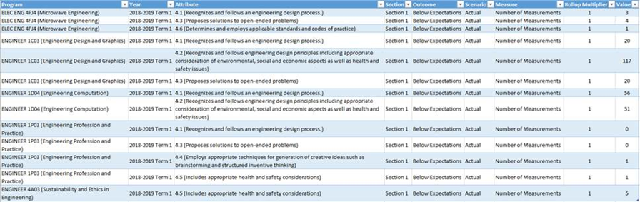

## Faculty and Curriculum Committee Recommendation Report

Displays the recommendations from the curriculum committee at both course and program level. This report can be viewed for any year where data is available. The data comes from the feedback provided in the Curriculum Committee Recommendations Input Template and as described in the Departmental Guide.

1. Press **View** next to Faculty and Curriculum Committee Recommendations Report
2. Select a Course/Program and Year
3. **Download** and remember the saved location of the report

To view an attached file:

* 1. Select a cell containing an attachment

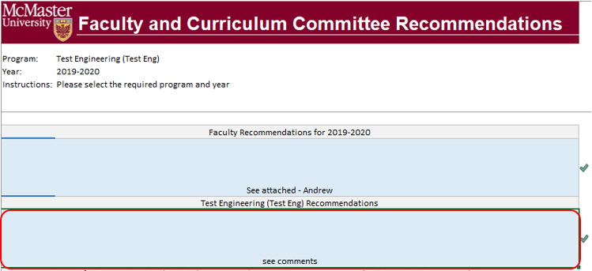

* 1. Click on **Comments** under **Vena** Tab
  2. On the right-hand side, select the attached file

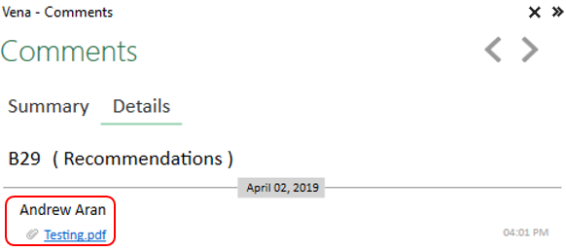

1. For macOS users, click  under Vena Comments
2. On the right-hand side, select the attached file

## Historical Course Measurement Report

Shows the historical trend for each course at different levels (indicator, attribute and all).

1. Press **View** next to Historical Course Measurement Report
2. **Download** and remember the saved location of the report
3. Select a Course (and Graduate Attribute if necessary)
4. If prompted, **Enable Content** and **Enable Macros**

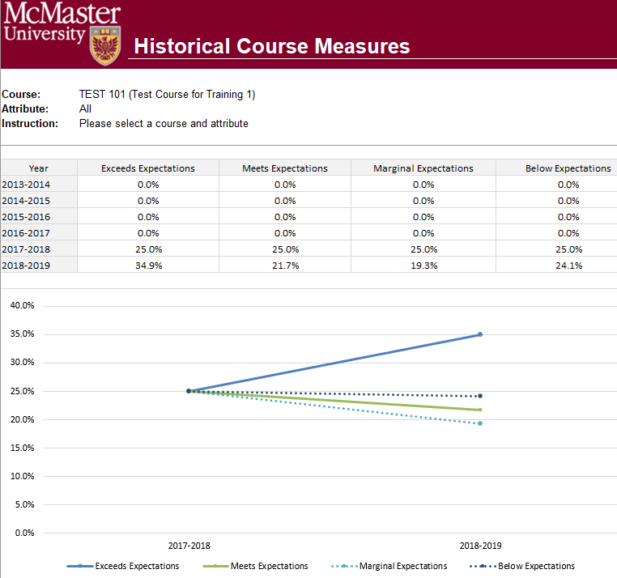

## Historical Program Measurement Report

Shows the historical trend for each program at different levels (indicator, attribute and all).

1. Press **View** next to Historical Program Measurement Report
2. **Download** and remember the saved location of the report
3. Select a Program (and Graduate Attribute if necessary)
4. If prompted, **Enable Content** and **Enable Macros**

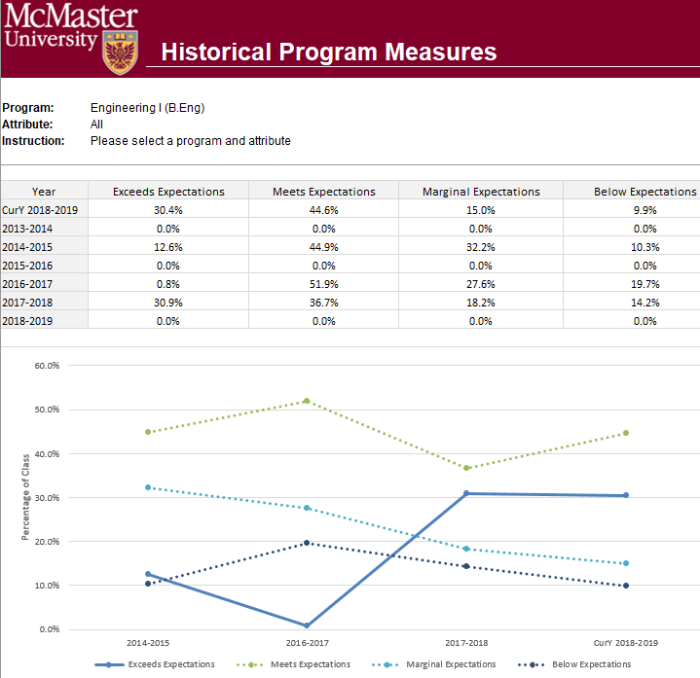

## Measurement Map Report

Indicates attributes the instructors will need to measure for a given year.

1. Press **View** next to Measurement Map Report
2. **Download** and remember the saved location of the report
3. Select a Program and Year
4. If prompted, **Enable Content** and **Enable Macros**

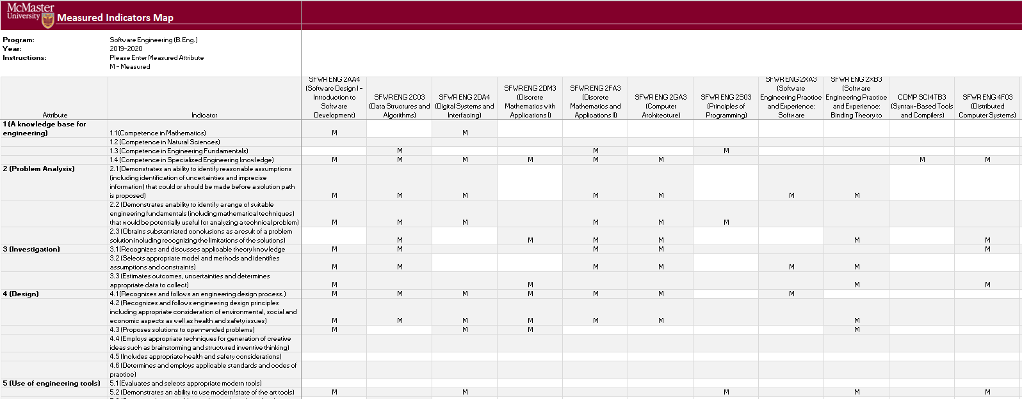

## Cascade

**\*\*\* Vena Feature currently available to Windows Users only \*\*\***

The cascade feature enables users to generate the same Vena report for multiple courses or programs. This feature eliminates the need to manually generate the same report for multiple courses.

### Generating a Mass Course Report

The steps below will show how to create

1. Select Contributor → Reports → Course Reports → **View**
2. Download and open the Course Report
   1. Click **Enable Editing** and **Edit Content** if the pop-up appears
3. Select a Course (belonging to the program), Year, Term, Section
4. Select the Vena Tab then click **Cascade**



1. For dimension, select **Program**

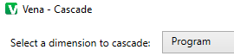

1. Select the courses belonging to the program (hold shift + click)

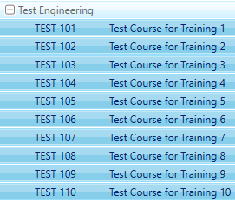

1. Change option from Cascade to Sheet to **Cascade to File**



1. Choose a location to save the files
2. Click **OK**
3. The Cascade feature will take approximately 5-10 minutes to complete

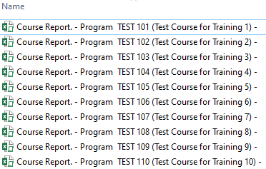

# Appendix I: Report Overview

|  |  |
| --- | --- |
| **Report Overview** | |
| **Report** | **Description** |
| Attribute Map Report | Displays all the courses for a program and the highest measure level for each Graduate Attribute |
| Attribute Map Summary Report | Similar to the Attribute Map Report, instead of displaying the level (A, D, I), the summary report displays an “X” to indicate that the course is measured for a specific attribute |
| CEAB Attribute Report | Displays a bar chart of the rubric data entered for each graduate attribute in a given program/course |
| Course Report | Displays the rubric data entered from the Rubric Input Template in a bar chart. Also contains (if any) continuous improvement plans |
| Curriculum Committee Recommendations Report | Displays the committee recommendations for the program and its courses |
| Historical Course Measurement Report | Displays the course's year to year trend of the measured expectations |
| Historical Program Measurement Report | Displays the program’s year to year trend of the measured expectations |
| Indicator Map Report | Displays all the Graduate Attribute Indicators and the lowest measure level for each course |
| Measurement Map Report | Assigns an “M” for each course measured for the year |
| Rubric Entry Report | Displays the rubric entry status, indicates if a course is measured, the instructor's name, the last user to save rubric data, and when it was last saved |

# Appendix II: Previous Modification Log

|  |  |  |  |
| --- | --- | --- | --- |
| **Version** | **Modification date** | **Author** | **Comments** |
| 1.0 | July 5, 2016 | Evan Situ |  |
| 1.1 | August 28, 2016 | Evan Situ | Split the instructor document added section 3.1 and 1.4 |
| 1.2 | November 21, 2016 | Evan Situ | Removed Other Resource |
| 1.3 | December 20, 2016 | Michelle Zheng | Updated sections 2-6 |
| 1.4 | January 2, 2017 | Spencer Smith | Updated timeline, instructor input, reports, submit button |
| 1.5 | January 9, 2017 | Spencer Smith | Addition of password change instructions |
| 1.6 | January 19, 2017 | Spencer Smith | Removal of request to use the Submit button |
| 1.7 | January 31, 2017 | Spencer Smith | Explicit statement that each indicator has to have at least one learning outcome |
| 1.8 | April 19, 2017 | Spencer Smith | Explanation of columns in the Rubric Input template |